Day 44

DIY

1. Create a Working directory and add files to it

Cmd : mkdir foldername

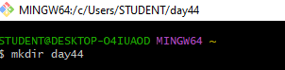

1. Initiate a git repository

Cmd : git init



1. Add the files to the staging area

Cmd : git add

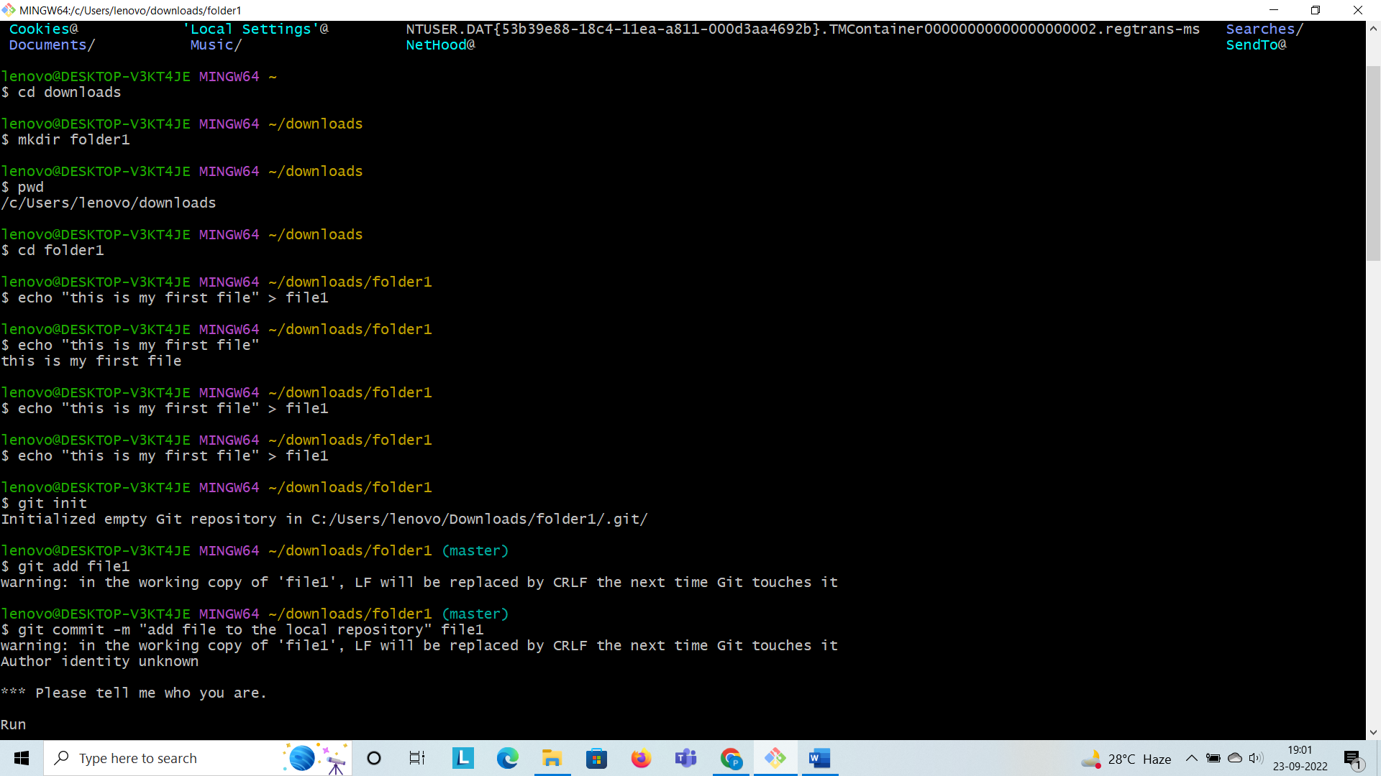

1. Commit the files to the local repository

Cmd : git commit –m “demo file” day44

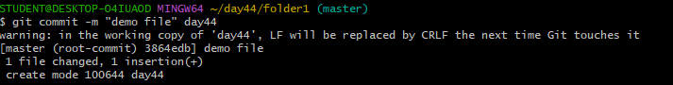

5.Create a new public remote repository

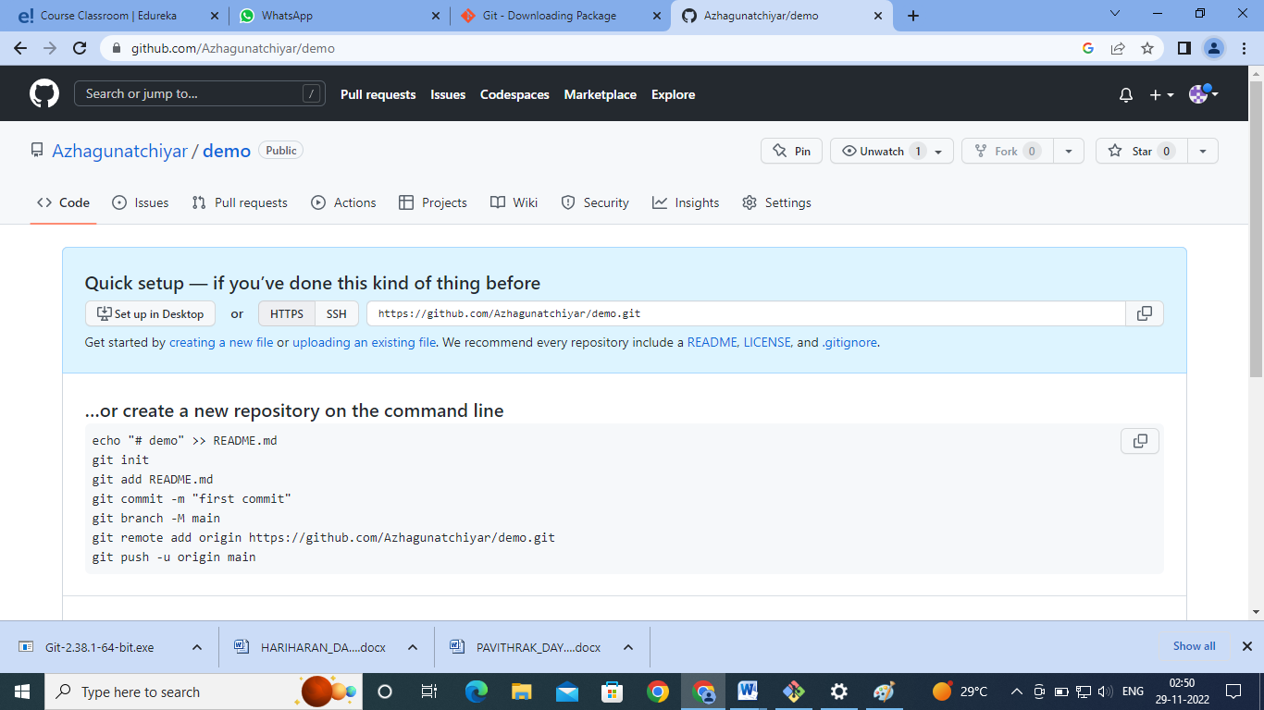

6.Add the remote repository path to the local repository

Cmd : git remote add origin <link of the repository>



7.Set and check the remote variable

Cmd : git remote

